**Verification(CADS4)** 2

1 DVM LDW CADS4 2

2 DVM eLKA RoadEdge 3

3 DVM LKA CADS4 3

3.1 sLKA HMI 4

3.2 sLKA Basic performance Test Track 4

3.3 sLKA Rating 5

3.4 sLKA Safety Goal 6

3.5 sLKA Reduced RWUP 6

3.6 sLKA Robustness 6

3.7 sLKA Docunmentation 6

**Verification(CADS4)**

In the verification section includes the following:

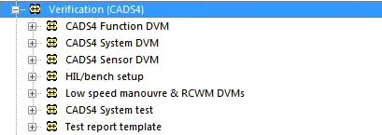

CADS4 Function DVM

The structure of function dvm document is explained below:

We are responsible for DVM LDW CADS4、DVM eLKA RoadEdge and DVM LKA CADS4

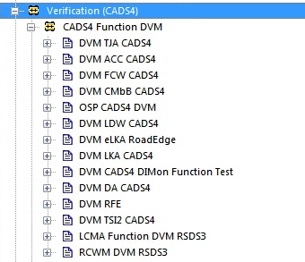

1 DVM LDW CADS4

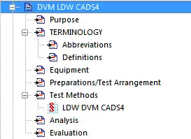

Volvo functional verification mainly tests the following:

1. LDW HMI
2. LDW Basic Performance Test Track
3. LDW Rating
4. LDW Safety Goal
5. LDW Documentation
6. LDW Reduced RWUP

2 DVM eLKA RoadEdge

This chapter contains the test scope of this DVM.The test scope contains all test specifications,test cases and links to requirement.

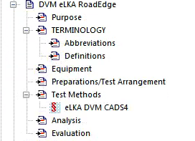

Volvo functional verification mainly tests the following:

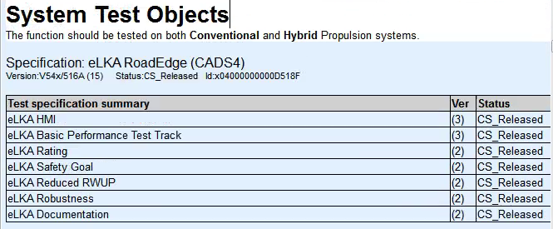

3 DVM LKA CADS4

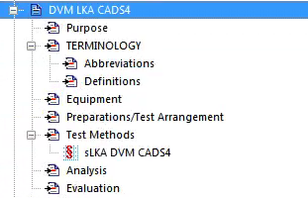

sLKA functional verification mainly tests the following:

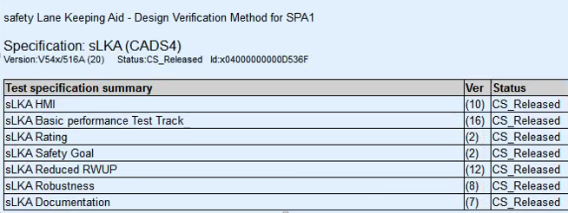

3.1 sLKA HMI

this chapter verify HMI interface function，which contain：

1. On/Off switch

2) Warning mode

3) Warning type

4) Factory setting

5) Last setting

6) Personal settings

7) Hands-off driving prevention

3.2 sLKA Basic performance Test Track

this chapter verify HMI interface function，which contain：

1. Lane marker on right side
2. Lane marker on left side
3. Lane markers on both sides
4. Warning and Steering Intervention Arbitration
5. LKA On->Off During Intervention
6. Scale down of intervention strength
7. Intervention/Warning Abortion
8. Intervention/Warning Suppression
9. Intervention Performance
10. Intervention Performance,Curve
11. Operational Host speed
12. LDW function
13. Staistical data storage
14. Regulation compliance
15. LDW and sLKA ogether with Pilot Assist
16. ABS & DSTC active

3.3 sLKA Rating

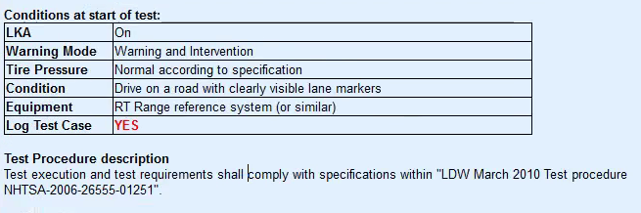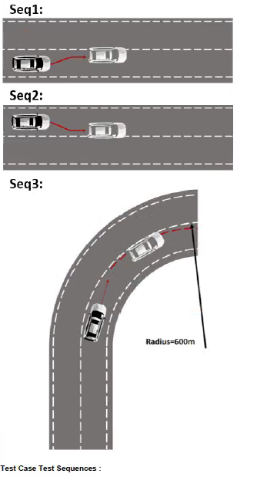5.4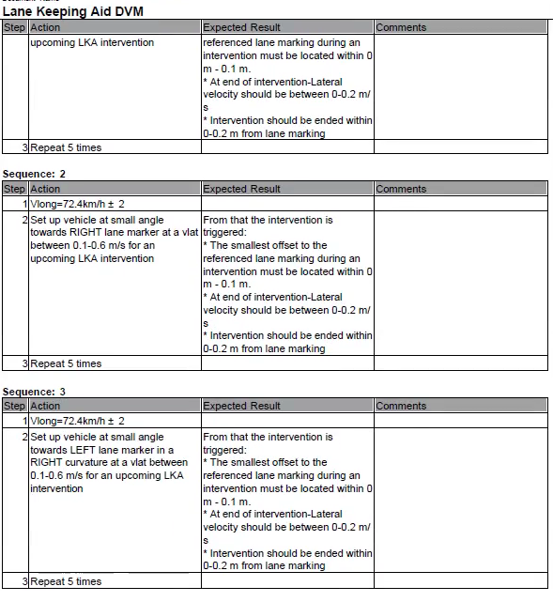

3.4 sLKA Safety Goal

3.5 sLKA Reduced RWUP

1. LKA Reduced RWUP test
2. Tunnel driving
3. Traffic density
4. Solid Line
5. Dashed Line
6. White Lane Markings on asphalt
7. Raised pavement markers
8. dashed+dashed(double line)
9. dashed+solid(double line)
10. solid+ dashed(double line)
11. solid+ solid(double line)
12. Yellow Lane Markings on asphalt
13. Yellow Lane Markings on concrete
14. Warning/Intervention Abortion
15. LDW operating envelope
16. Lane Width

3.6 sLKA Robustness

1. LKA Reduced RWUP test
2. LKA trailer
3. LKA Maximum vehicle load

3.7 sLKA Docunmentation

1. LDW/LKA sensor documentation
2. Sensor static Envionment review
3. LDW: Lane Markings
4. LDW: usable Road Surface Delimiters
5. LKA use case